Mesh 1:

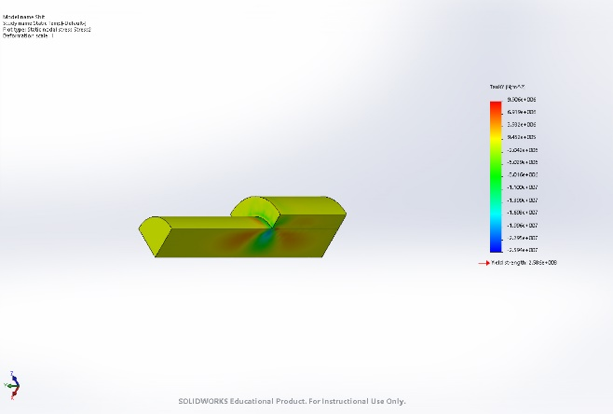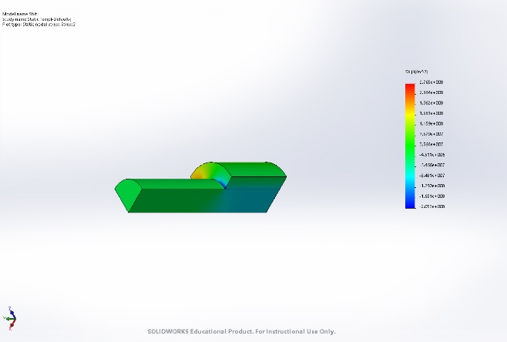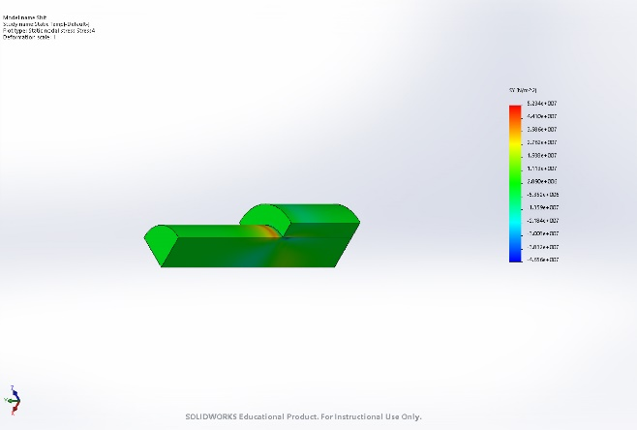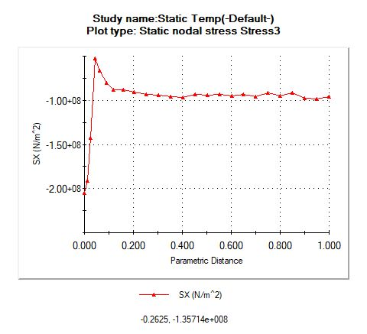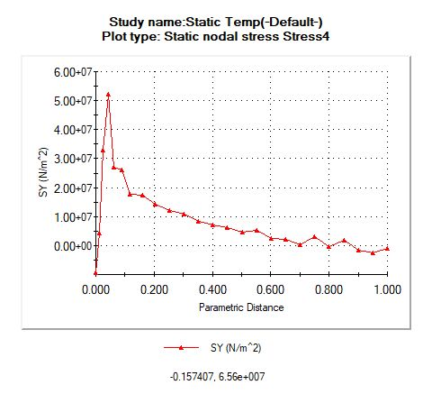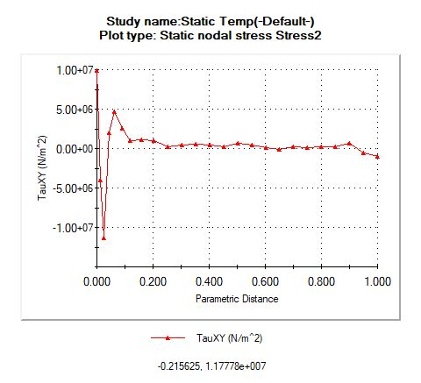

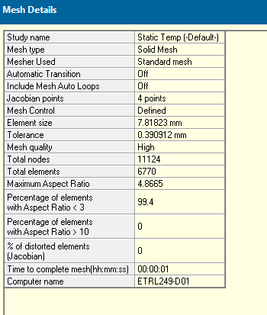

Mesh 2:

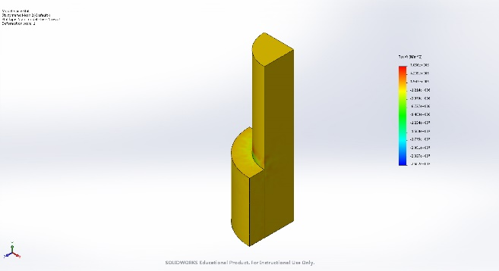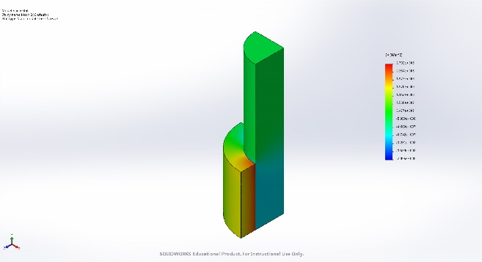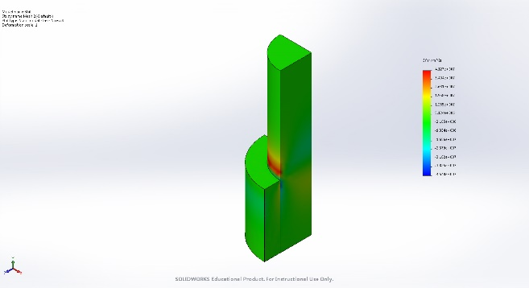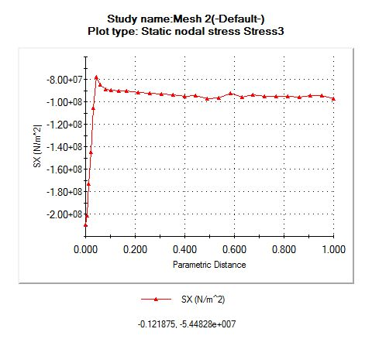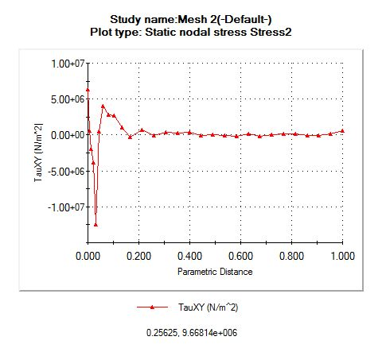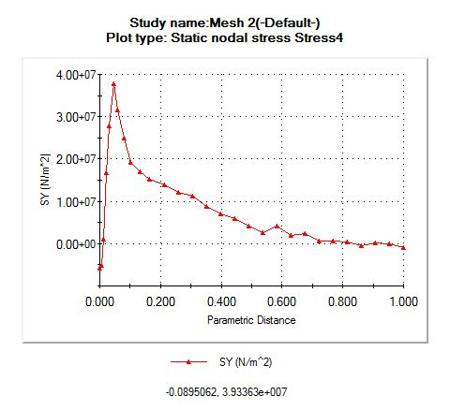

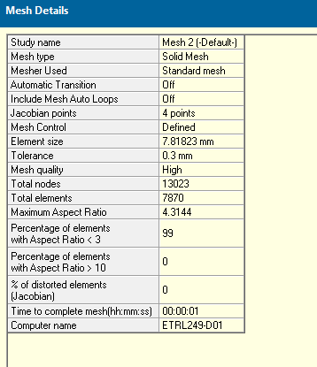

Mesh 3:

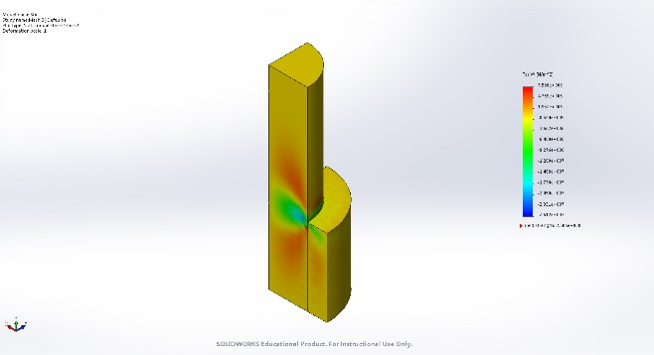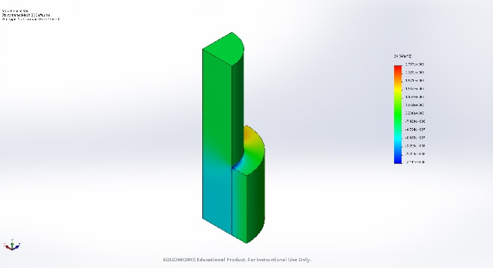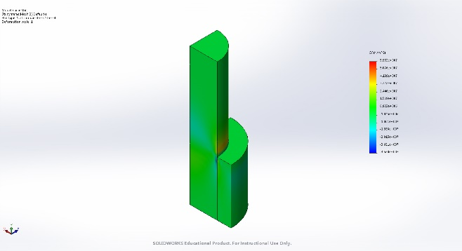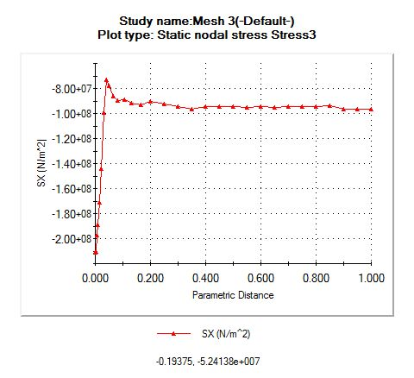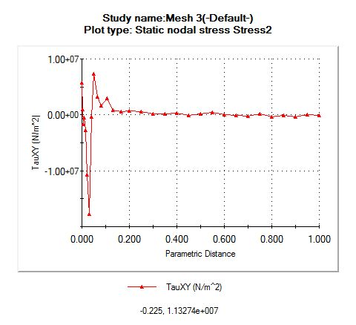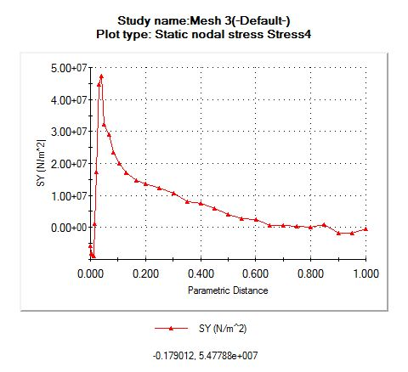

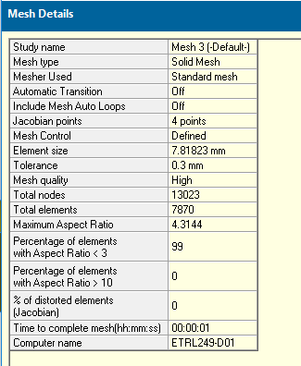

Discussion:

The value between the first and second for the stresses increases exponentially, but the difference between the second and third isn’t as extreme. It may not be necessary to make the third one, but I would be safe and go with it do to a lack of data determining if it converges.

Part 2:

Value at mesh 1 for the contour plots on stress x is a lot higher. For the y stress plots it increases by 1e7 for the increasing mesh intensity. For shear it all fluctuates and starts at different points, but tappers out around zero for all. For all seem to start at an exponential growth then rapidly decline to even out. The first mesh does not start at the same spot as the higher mesh densities, and the higher mesh density has more fluctuation before the jump. Also, the stress on the r axis tappers towards -1e8 for all and the others go to zero. The higher mesh densities match up, but the first one’s maximum’s value does not. I would say you cannot get exact values at the edge for the sole reason the values fluctuate between meshes in an unpredictable manner.

Part 3:

I believe the mesh should stay at point E. The spot is an area of great change. Although, the higher densities seem to add some more complicated data to the contour plots, the data is converging with the higher density. For a proper and quick analysis, it should be kept for the most optimal data. It is also representing the most accurate representation of what is happening on the whole part. Although, there are concerns, because the part as a whole should behave the same around the body, from my assumption, and it doesn’t seem to be the case.